Station 1:
Pregnancy: First Trimester

Objective: To understand what happens during the first 0-14 weeks of development

Record the information in your green packet

Day 1: Typically “day 1” is on (or around) the day of ovulation. On this day the mature ova has been released from the ovaries and is ready to be fertilized. Human life begins at fertilization. On day 1, the sperm “swims upstream” at a rate of 3 inches/hour. The ova are 30,000 times larger than the sperm cell. That’s huge!!! When the sperm cell meets the egg cell, a single cell with 46 chromosomes is formed.
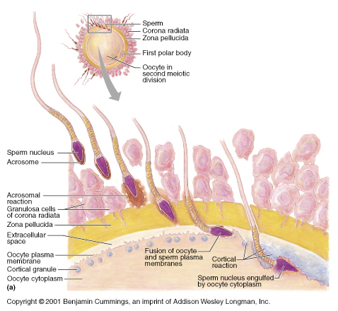

7-9 Days: The group of cells attaches the uterine lining and burrow down in where they will receive plenty of blood flow for the next 40 weeks! We refer to this bundle of cells as an “embryo”.

18 Days: After just 2 ½ weeks, an actual heart muscle actually pulsates!!

20 Days: The nervous system lays down a foundation.

25 Days (one month): The heart is now beating regularly and the digestive system is forming. And get this… eyes and ears are actually visible!

6 Weeks: Brain waves and body movements are now visible through diagnostic tests.
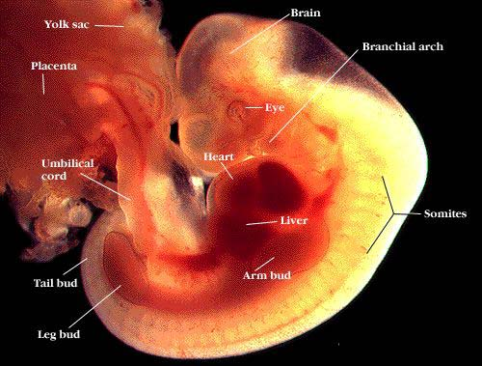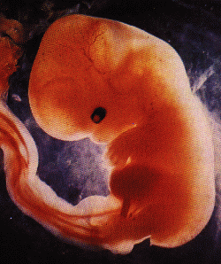

8 Weeks (2 months): All body parts are not present (it doesn’t looks more like an alien than a human… but the parts are there!). The FETUS now has a large head with a brain and facial features, and fingers and toes! The fetus is even hiccupping, kicking, and waving.

10 Weeks: All organs are now functioning including the stomach, liver, and brain. The fetus can swallow, suck, and yawn. Although the fetus is very well developed, it still cannot survive outside of the womb. The fetus is approximately 3 inches long.
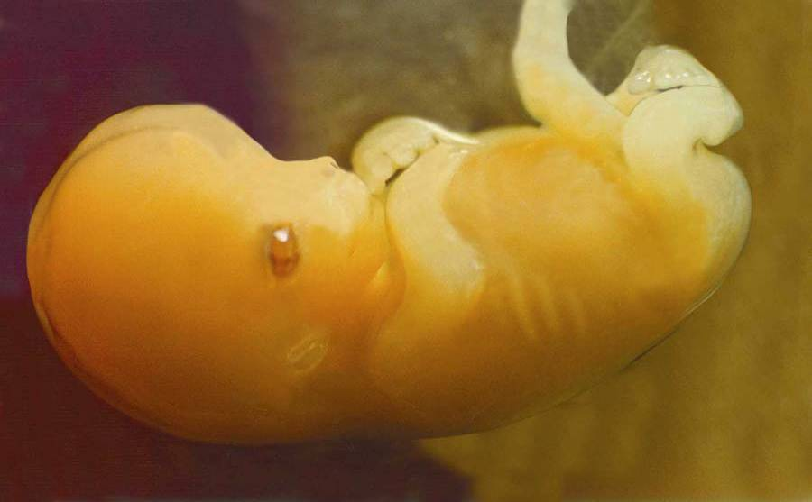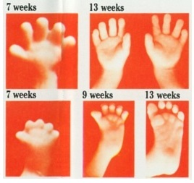

Station 2:
Pregnancy: Second Trimester

Objective: To understand what happens during weeks 15-28 of development

Record the information in your green packet

16 Weeks (3 ½ - 4 months): The face becomes much more clear by this time and the first signs of gender appear. The excretory system and the skin are developing. And by this point the hearing is fully developed, so the fetus can be soothed by familiar voices like that of it’s mother! Mom can now start to feel the kicks and movements of this 6 ½ inch fetus!

20-24 Weeks (5 months): At this point the growth rate slows. Did you know that if a fetus continued to grow at the rate that is grows during the 1st trimester, it would be larger than the size of the sun before it was born? THAT’S HUGE!! During this time the fetus will actually open it’s eyes and starts to develop fine hair. The doctor can now hear the heart beak through the use of a stethoscope. By this time, mom is half way there and her fetus is about 1 pound and 10 inches long.
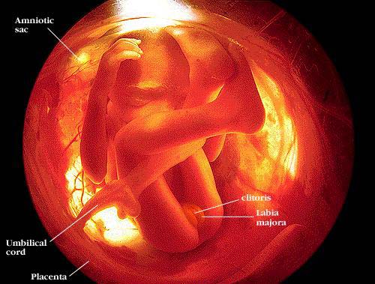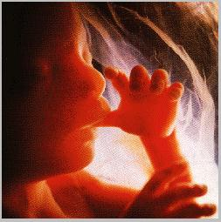
IT’S A GIRL!!!!

26 Weeks (6 months): Although it’s not idea, this is the earliest age of survival outside of the mother’s uterus. If a fetus is born at 26 weeks, it has a 50% change of survival. The fetus is about 1 foot long by now and is continuing to grow and mature. The fetus is responsive, and its heart rate will fluctuate with outside sounds or pressures. It doesn’t look like an alien any more… although still looks like a miniature old man!
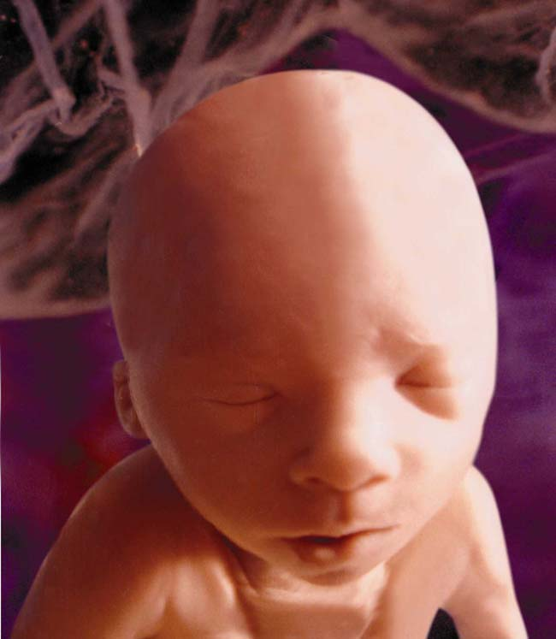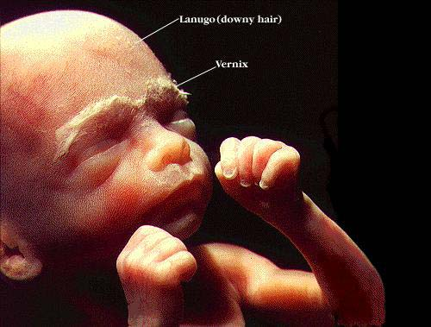

Station 3
Pregnancy: Third Trimester

Objective: To understand what happens during the weeks 29-40 of development

Record the information in your green packet

26 Weeks (6 ½ - 7 months: The fetus is getting close. In fact, it can recognize particular voices. Because the fetus is fully developed, it has an 80% chance of survival if born at this time, however, it would be ideal to allow it more time to develop enough fat cells to maintain body temperature. The fetus is about 2 pounds 4 ounces and 14 inches long! It’s going to be a big one!!!

32 Weeks (7 ½ - 8 months): Yep…. Still growing and developing. The fetus is about 3 pounds, 11 ounces.
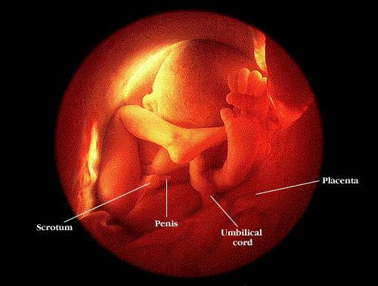

37 Weeks (8 ½ - 9 months): Any baby born before this time is considered to be “pre-mature”. This fetus is about 5 pounds 9 ounces.

40 Weeks (9-10 months): The fetus is “full term”…. And it’s time to get this kid out of here before he over cooks!! The average full-term baby born in the United States is 7 pounds 6 ounces, and 20 inches long!

Go to p 472 in your Health book for more details
Station 4:
Anatomy Review
Objective 1: to know male/female anatomy and the function

Match the definition on the pink and blue cards to the appropriate male and female anatomy

Station 7:
Physical Changes
Objective: to understand the physical changes to the mother during pregnancy

Physical Changes During Pregnancy (add to the list in your green packet): An expecting mother will experience a LOT of physical changes. These changes may vary from pregnancy to pregnancy. Some of the common physical changes include:
Skip menstrual period/spotting
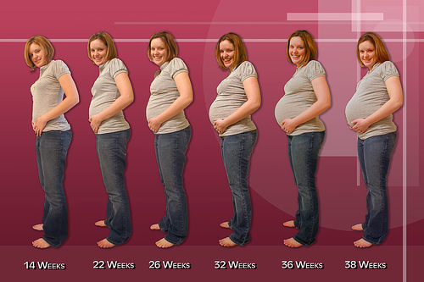
Tender, enlarged breasts
Increased urination
Heightened emotions
Heightened senses
Morning sickness
Cravings
Fatigue
Constipation
Uterus/abdomen expand
Increased urination
Difficulty breathing
Stretch marks
Varicose veins
Weight gain

Read the information below and see if you can identify the structures on the picture. (Answers are on the back)

Uterus: Also known as the “womb”. The uterus is a hollow muscular organ that provides a home for the baby during pregnancy. The uterus will change shape and stretch up to 60% of it’s original size in order to accommodate the growing fetus.

Amniotic Sac: This “bag of water” provides a seal to protect the fetus from infection. This sac will break prior to labor allowing the baby’s weight to sit heavy on the cervix. This will cause the cervix to dilate in order for the baby to pass through the vaginal opening.

Amniotic Fluid: The fluid in the amniotic sac acts as a shock absorber and keeps temperatures constant. The amniotic fluid contains DNA cells from the baby itself. The baby will also develop its lungs and learn to breath by inhaling this fluid. But don’t worry, it won’t drown as it is still getting oxygen from umbilical cord!

Umbilical Cord: This cord attaches the growing fetus to its mother. The umbilical cord serves as the lifeline for the growing fetus as it carries blood, oxygen, nutrients, and waste products between the fetus and placenta. The umbilical cord is about 2 feet long and contains 2 arteries and 1 vein. The umbilical cord will be clamped and cut off after birth. The remaining end of the umbilical cord will dry out and fall off naturally during the first few weeks of life. This leaves what we call the “belly button”.

Placenta: The placenta is a sack of blood and nutrients that attaches itself to the wall of the uterus. The placenta picks up nutrients and oxygen from the mother’s blood and removes waste products from the baby. The placenta is responsible for holding the fetus to the wall of the uterus during fetal development. Did you know that some mothers eat their placenta after the child is born? It’s actually quite healthy with all of those nutrients… and also a little nasty if you think about it!!

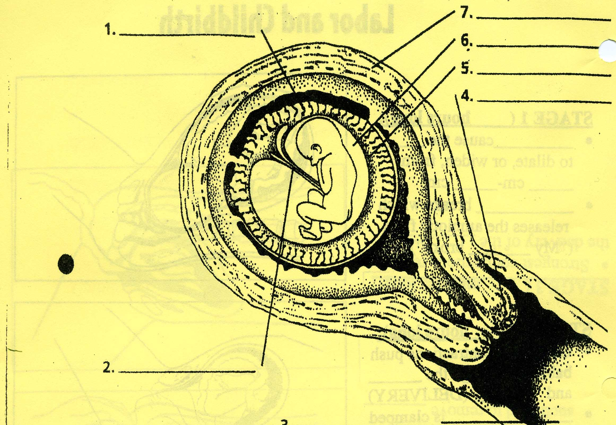

Can you list the parts of the female reproductive system during pregnancy?

Here’s the key:
- Placenta
- Umbilical Cord
- Vagina
- Cervix
- Amniotic Sac
- Amniotic Fluid
- Uterus

Station 5: The Birth Process

Objective: to understand what happens during each stage of labor

Record the information in your green packet

Labor: Labor is a 3-step process. During labor, the uterine muscles contract and relax causing the cervix to dilate. This takes a long time! In fact, the average labor for a woman’s first baby is 18 hours. It gets easier though; the average labor for all babies in the United States is only 8-12 hours. Labor typically begins 40 weeks after the last menstrual period. A baby born prior to 37 weeks is considered to be “premature”.

In a nutshell, this is what labor is like for mom and baby…
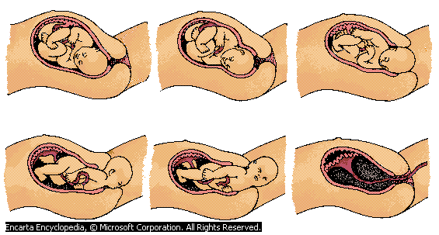

Labor Stage 1: The first stage of labor can last anywhere from 2-24 hours. During the time the mother will experience contractions of the uterus causing the cervix to dilate or widen. The cervix must dilate from 2 ½ cm – 10 cm. That’s a lot of widening that the muscle must do! Often times, this is the result of the “water breaking”. The amniotic sac will lose the ability to hold the pressure of the fetus any longer an break releasing the amniotic fluid. If the sac doesn’t break on it’s own, the doctor can use a tool that looks like a crochet hook. He inserts the tool vaginally and uses the hook to break the sac manually.

Labor Stage 2: The second stage of labor can last anywhere from ½ an hour – 2 hours. During this stage of labor the actually “delivery” will take place. Contractions will continue during this phase. The doctor will instruct the mother to bear down on the fetus during contractions in order to help the baby move through the fetus and birth canal.
After the baby is delivered, the umbilical cord is clamped and cut. The baby’s nose and mouth will be suctioned to remove the nose plugs and mucus. At this time, mothers wait anxiously to hear their baby take their first breath and begin to cry!
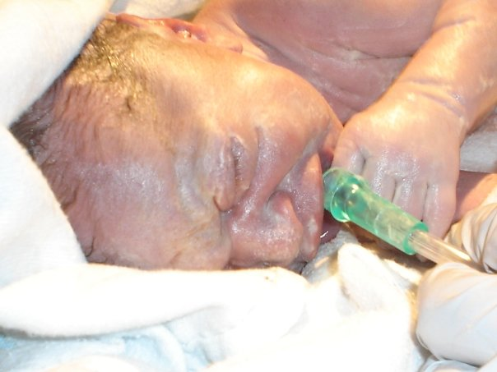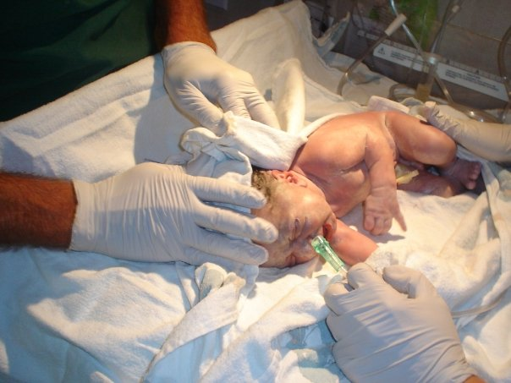

Labor Stage 3: After the baby is born, mom isn’t finished! The umbilical cord has been clamped and cut from the baby but is still connected to the placenta. Mom will now experience more intense contractions for 15-20 minutes followed by the “after birth”… Also referred to as the delivery of the placenta. Mom essentially has to give birth to the placenta. If the placenta, or part of the placenta, are left in the uterus it can cause major pain and problems.

Labor and Delivery: The best position for delivery is head down. A delivery can happen one of two ways.
- Vaginal Delivery – A vaginal delivery is the most desireable delivery as the recovery is much shorter. A vaginal delivery is defined by the baby moving through the cervix and birth canal naturally.
BREACH: If the baby isn’t coming head first there may be complications. When the baby is coming buttocks first, it’s call “breach”. In these cases, the doctor will begin to consider a Cesarean Section.
- Cesarean Section – Also known as a “C-Section”. There are many reasons why a doctor or mother would choose a C-Sections. Some reasons would include a breach baby, a birth mother with a sexually transmitted infection, a birth mother who has previously had a C-Section, a drop in the baby’s heart rate, a change in the status of the mother’s health, or any sudden changes in the health of the mother or her fetus. In order to complete a C-Section the doctors will insert an incision thru the mother’s abdomen and uterus. He will then manually remove the baby, clap the umbilical cord, suction the mouth and nose, and remove the placenta prior to stitching the mother back up.
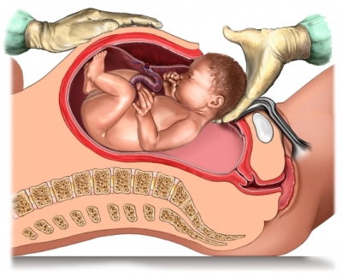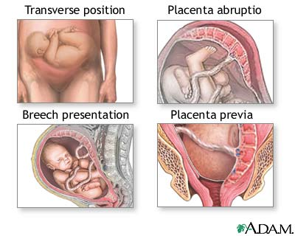
What a C-Section Looks Like. Why Do a C-Section?

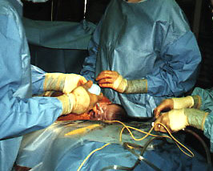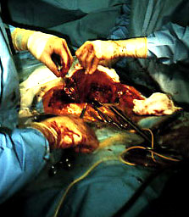
Removing the baby via C-Section. Removing the placenta via C-Section.

Station 6:
A Healthy Pregnancy

Objective: Identify risk factors in pregnancy and what the woman can do to minimize them

Make 2 lists (at the top of the page in your green packet titled Pregnancy) of the good habits a mother should have and bad habits she should avoid during pregnancy.

Read p474-476 in Health book and then read below

Detecting Problems With The Baby:
- Ultrasound – An ultrasound is a diagnostic technique that uses sound waves to create pictures of internal body structures. We can see physical deformities and gender through an ultrasound
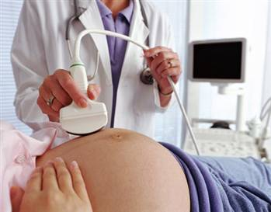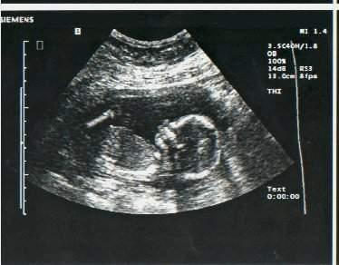
- Amniocentesis – An amniocentesis is another diagnostic technique that removes fetal cells from the amniotic fluid. This fluid contains DNA from the fetus and can be used to diagnose genetic problems. Essentially, the doctor inserts a needle through the mother’s abdomen and into the uterus where they can then remove a sample of the amniotic fluid to be tests. No, this doesn’t pop the amniotic sac. The sac is much like our skin. After being punctured, it seals itself back up until the fetus is ready to deliver.
Why would someone do this test?
- You or your partner may have a genetic condition, which may be passed on to the baby.
- There is a risk that a condition may be passed on to your baby.
- You have had a pervious child affected by a genetic condition.
- You have had another type of test that is done during pregnancy (such as an ultrasound or blood test). It has show that there is an increased risk that your baby has a genetic condition.
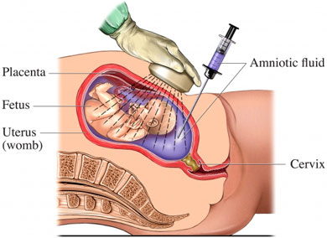

Weight Breakdown: It is normal for an expecting mother to gain between 25-35 pounds during pregnancy. Gaining more weight than this is not healthy for mom or baby! And, it’s hard to lose it afterward! Here’s the breakdown of where this extra weight actually comes from:

Blood = 3 lbs
Breast Tissue = 2 lbs
Uterus = 2 lbs
Baby = 7.5 lbs
Placenta = 1.5 lbs
Amniotic Fluid = 2 lbs
Fat = 7 lbs
Retained Water = 4 lbs

Nutrition During Pregnancy: An expecting mother should eat from all 5-food groups. She will need extra iron, calcium, vitamins, and minerals. Most doctors will recommend that expecting mothers take a multi-vitamin to ensure nutrient needs for their developing fetus. Also, mom is “eating for 2 “, right? Well yes… and no! She certainly has to eat the nutrients for her and her developing fetus, but that does not mean that she needs two of everything. She simply needs 200-300 more calories each day. This is the equivalent to about ½ a sandwich.

Exercise During Pregnancy: During the first and second trimesters of pregnancy, an expecting mother can exercise normally. Most doctors will advise expecting mothers to listen to their bodies. If they are uncomfortable during exercise, change the exercise. During the third trimester of pregnancy many expecting mothers will report pressure and lack of comfort during exercise and will chose activities like biking rather than running. Also, it is advised that expecting mothers avoid contact sports during the third trimester of pregnancy.
When lifting weights, consult your doctor. Pregnant women may still lift weights but should alter some exercises (such as sit ups) in order to avoid cutting off oxygen flow to the fetus.

*** REMEMBER: The first trimester of pregnancy is the most crucial time. Many mothers may not even know they are expecting. It is difficult to change your eating and exercise habits once your pregnant if you don’t know you are!! It is recommended that all women keep a healthy lifestyle prior to pregnancy in order to maintain a body that can house a healthy developing baby!

