**Archery Review Sheet**

Archery skill was of vital importance for thousands of years. It literally provided means of survival. It is generally agreed that man started using crude archery tackle some ten to twenty thousand years ago.

Archery became a sport in America after a group of Philadelphia gentlemen founded the United Bowmen in _________. The National Archery Association was founded in _________. Archery became a gold medal sport in the__________________________. The ___________________ bow is used by _____________ Archers. An arrow shot by this bow travels at more than 150 mph.

**The Bow**

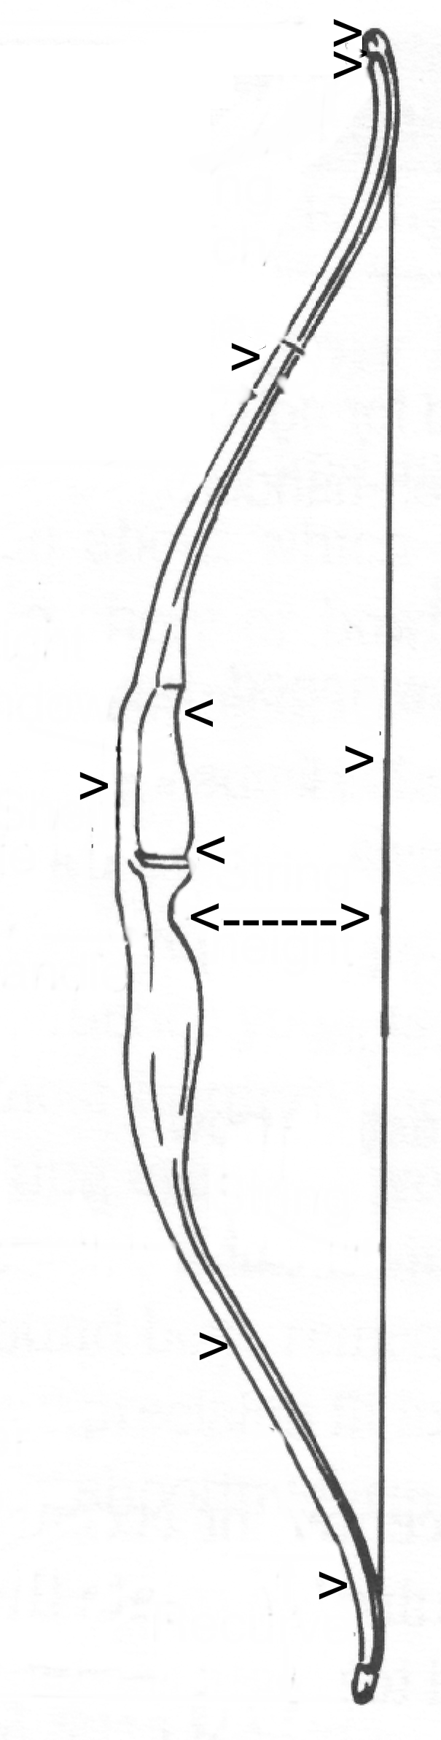**EQUIPMENT-Label the Bow**

**All equipment is called ________.** 4

**Bow** 8

1. __________ – side of bow that faces the target when shooting
2. _______– side of bow that faces the archer when shooting 1
3. ______ – held in archer’s hand 6
4. _____ – above and below the handle 3
5. ____________– wrapping of string in the center of the string that receives, wear from nocking and drawing 5
6. _______________ – top of handle where arrow sits
7. __________ – linen with loops at either end 2
8. __________ – where the loop of the string fits into the groove 7
9. __________ – tie end of the string 4

9

**The Arrow-Label the Arrow**

**SCORING**

Six arrows shot in succession is called an end.

The highest possible score for one end is (6 arrows) x 10 points = 60 points.

Values

* Yellow – 10x, 10, _____ points
* Red – 8,7 points
* Blue – _____, ______ points

* Black – 4, 3 points
* White – 2,1 point
* Petticoat (area outside the white circle) – _______ points
* Arrow cutting two colors receives higher point value



**SAFETY AND CARE OF EQUIPMENT**

Whistle Commands

_______ Blasts – “Archers may walk to_______________________.”

One Blast – “Archers may ________________their bows and begin shooting.”

Three Blasts – “Archers may walk to the target line___________________.”

______________ or More Blasts – “STOP SHOOTING and put your arrow back in your quiver.”

**Name 7 safety procedures**

1.

2.

3.

4.

5.

6.

7.

**List the 6 steps to shooting**

**Explain the Common Faults of Shooting.**

**Scoring**

|  |  |  |  |  |  |  |  |  |  |
| --- | --- | --- | --- | --- | --- | --- | --- | --- | --- |
| Name: | | | | | Date: | | | | |
|  | | | | | Shooting Lane: | | | | |
| Yardage | 1 | 2 | 3 | 4 | | 5 | End Total | Total Score | X |
|  |  |  |  |  | |  |  |  |  |
|  |  |  |  | |  |  |  |  |
|  |  |  |  | |  |  |  |  |
| Total Score | | | | | | |  |  |  |
|  | | | | | | | | | |
| Yardage | 1 | 2 | 3 | 4 | | 5 | End Total | Total Score | X |
|  |  |  |  |  | |  |  |  |  |
|  |  |  |  | |  |  |  |  |
|  |  |  |  | |  |  |  |  |
| Total Score | | | | | | |  |  |  |